TASK 1: Local Repository Setup
- Create a new project folder.
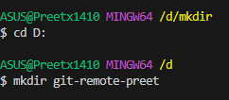
- Initialize Git in the folder.
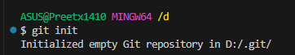
- Create a file named index.txt
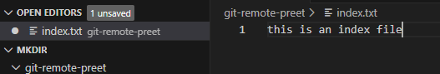
- Add content to the file.
- Check repository status.
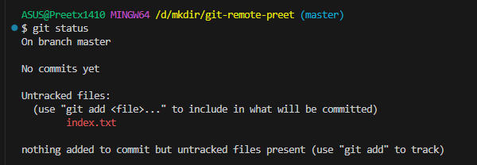
- Stage all changes.
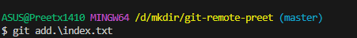
- Commit the changes with an appropriate message.
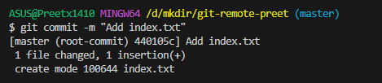

TASK 2: Remote Repository Creation
- Create a new GitHub repository.
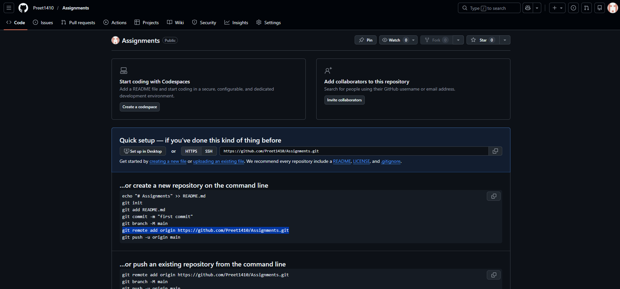

TASK 3: Connect Local Repository to Remote

- Add the GitHub repository as remote origin.
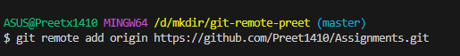
- Verify remote connection.
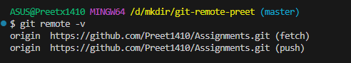
- Rename the current branch to main.
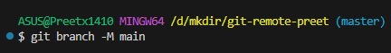

TASK 4: Push Local Changes to Remote
- Push the local main branch to the remote repository.
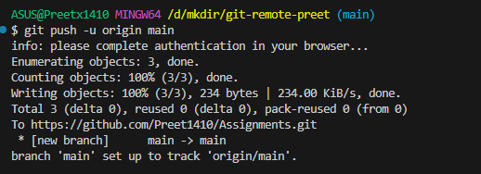

TASK 5: Branch Creation and Work
- Create a new branch named FirstBranch.
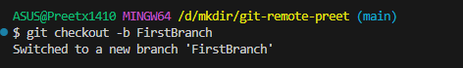
- Switch to the newly created branch.
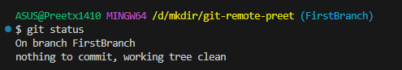
- Create a new file named notes.txt.
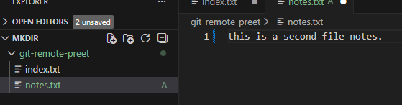
- Add content to the file.
- Stage the changes.
- Commit the changes.
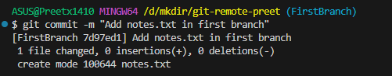

TASK 6: Merge Branch into Main
- Switch back to the main branch.
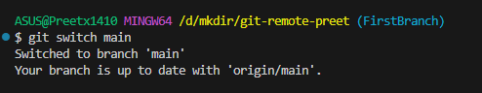
- Merge FirstBranch into main.
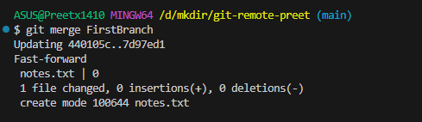

TASK 7 – Final Sync with Remote
- Push the updated main branch to the remote repository.
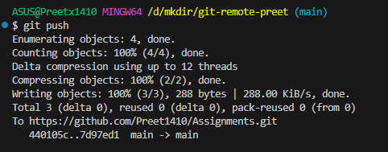

TASK 8 – Simple Pull
- Navigate to the correct local Git repository folder.
- Verify the current branch is main.
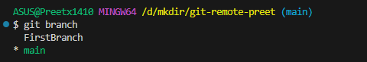
- Check the working tree status.
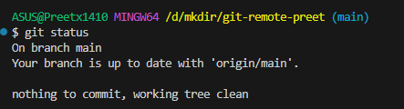
- Pull the latest changes from the remote repository.
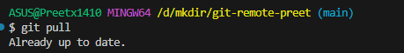
- Verify that the pull is successful.
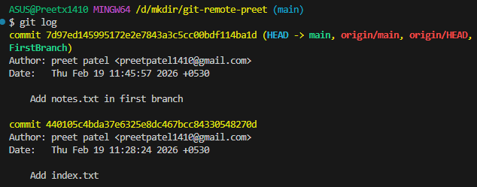

TASK 9 – Push and Pull with Conflict Resolution
- Navigate to the correct local Git repository folder.
- Ensure you are on the main branch.
- Change the content of the index.txt file and save the changes
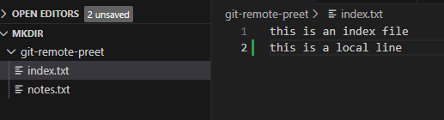
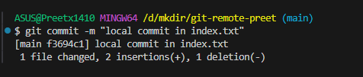

- Navigate to the correct remote Git repository folder.

- Ensure you are on the main branch.

- Change the content of the index.txt file and save the changes

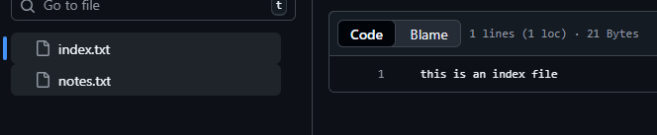

- Attempt to push local changes to the remote repository.

- Observe the push rejection error.
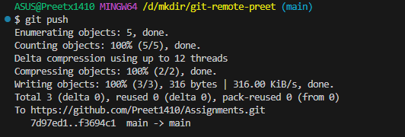
- Pull remote changes into the local branch.
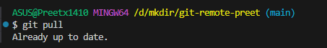

- Resolve merge conflict if it occurs.

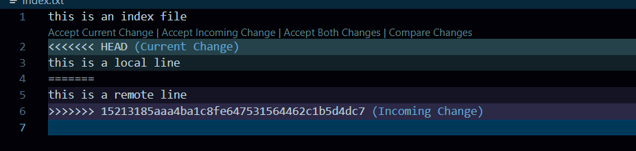

- Commit the merge resolution.
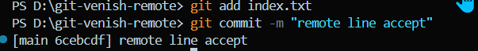

- Push the updated branch to the remote repository.

TASK 10 - Clone an Existing Repository
- Copy the GitHub repository URL.
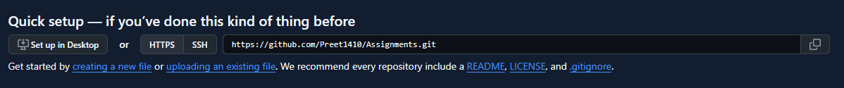

- Navigate to a parent directory (not inside another repo) in local.

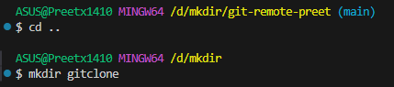

- Clone the remote repository.

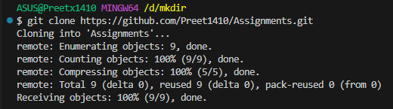

- Navigate into the cloned folder.

- Verify the current branch.

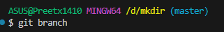

- Verify the remote connection.
